**RhythmicTunes: Your Melodic Companion**

**Ideation Phase**

**Brainstorm & Idea Prioritization**

|  |  |
| --- | --- |
| Date | 10 March 2025 |
| Team ID | SWTID1741256813147528 |
| Project Name | Rhythmic Tunes |
| Maximum Marks | 4 Marks |

**Brainstorm & Idea Prioritization Template:**

Brainstorming provides a free and open environment that encourages everyone within a team to participate in the creative thinking process that leads to problem solving. Prioritizing volume over value, out-of-the-box ideas are welcome and built upon, and all participants are encouraged to collaborate, helping each other develop a rich amount of creative solutions.

Use this template in your own brainstorming sessions so your team can unleash their imagination and start shaping concepts even if you're not sitting in the same room.

Reference: <https://www.mural.co/templates/brainstorm-and-idea-prioritization>

**ACKNOWLEDGEMENT**

We extend our sincere gratitude to our mentors, instructors, and peers who have supported us throughout this project. Their valuable insights, technical expertise, and encouragement have been instrumental in the successful completion of the "Rhythmic Tunes" music streaming application.

We are deeply appreciative of our institution for providing us with the necessary resources, infrastructure, and academic support to help us execute this project effectively. Special thanks to our project guide, whose constructive feedback and technical knowledge enabled us to enhance the application's features and functionalities.

We also extend our gratitude to our friends and family for their unwavering support, patience, and motivation throughout this journey. Finally, we thank the online developer communities and open-source contributors whose resources and guidance helped us overcome challenges and build a high-quality application.

**Brainstorm, Idea Listing and Grouping**

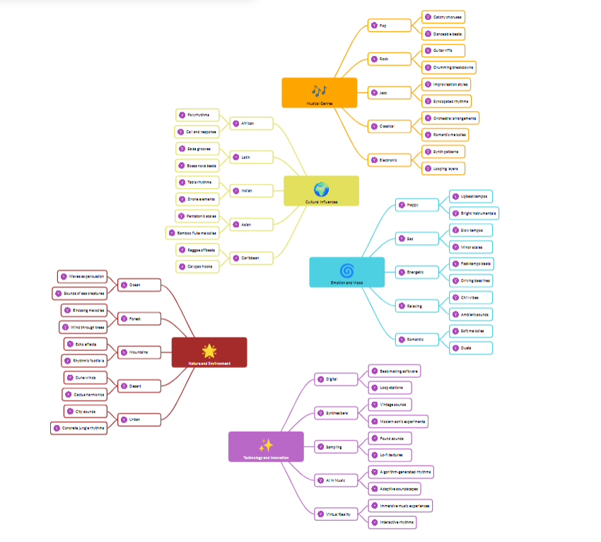

**The image is a mind map that categorizes different aspects of music and sound influences. It is structured into five main branches, each with subcategories:**

1. **Musical Genres (Orange)**
   * **Covers different styles of music such as Pop, Rock, Jazz, Classical, and Electronic.**
   * **Highlights key characteristics like catchy choruses in Pop, improvisation in Jazz, and synth patterns in Electronic music.**
2. **Cultural Influences (Yellow)**
   * **Explores how different cultures contribute to music, including African, Latin, Indian, Asian, and Caribbean influences.**
   * **Mentions elements like polyrhythms in African music, tabla rhythms in Indian music, and bamboo flute melodies in Asian music.**
3. **Emotion and Mood (Blue)**
   * **Connects music to emotions such as happiness, sadness, energy, excitement, and romance.**
   * **Describes musical features like upbeat tempos for happiness, slow tempos for sadness, and driving bass lines for energy.**
4. **Natural Environment (Red)**
   * **Examines how nature and surroundings influence music.**
   * **Includes categories like ocean sounds (waves), forests (wind through trees), mountains (echo effects), and urban environments (city noise).**
5. **Technology and Innovation (Purple)**
   * **Highlights the role of modern technology in music creation.**
   * **Discusses digital innovations, sampling, AI in music, and virtual reality for immersive experiences.**